## Supplementary Material

Table S1. (a) Summary of the seven Ecosystem’s characteristics (Figure 1). See Zhao et al. (2019) for details.

|  |  |  |  |
| --- | --- | --- | --- |
| **Ecosystems** | **Location** | **% ocean area** | **Distinguishing characteristics** |
| 1 | Offshore Northern Atlantic and edge of the temperate Southern Ocean | 9 | Cold temperate |
| 2 | Offshore middle of Southern Ocean and Northern Pacific | 17 | Boreal, high nutrients, |
| 3 | Coastal Areas excluding Polar regions | 7 | High and variable chlorophyll and productivity, high wave height |
| 4 | Offshore Tropics | 24 | Tropical and high PAR |
| 5 | Arctic Ocean | 10 | Polar, high ice cover, low wind and salinity |
| 6 | Offshore subtropics | 22 | Subtropical |
| 7 | Antarctic shelf | 12 | Polar, high nutrients and ice cover, lower oxygen |

(b) The variables used for mapping the seven Ecosystems (obtained from Basher et al., 2014).

|  |  |  |
| --- | --- | --- |
| **Physical** | **Biochemical** | **Nutrients** |
| Temperature | pH | Saturated Oxygen |
| Wind Speed | Photosynthetically Active Radiation | Utilized Oxygen |
| Slope | Chlorophyll-α | Silicate |
| Land Distance | Primary Productivity | Phosphate |
| Surface Current |  | Dissolved Oxygen |
| Diffuse Attenuation Coefficient |  | Nitrate |
| Salinity |  | Calcite |
| Wave Height |  |  |

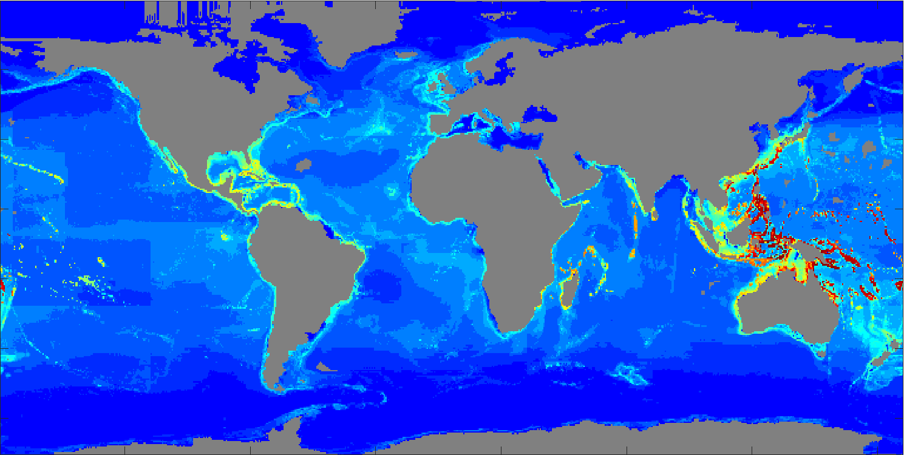

Figure S1. The map of global species richness from AquaMaps (Kaschner et al., 2016). The colours represent the species richness from low (blue) to high (red, up to 8,070 species per cell).

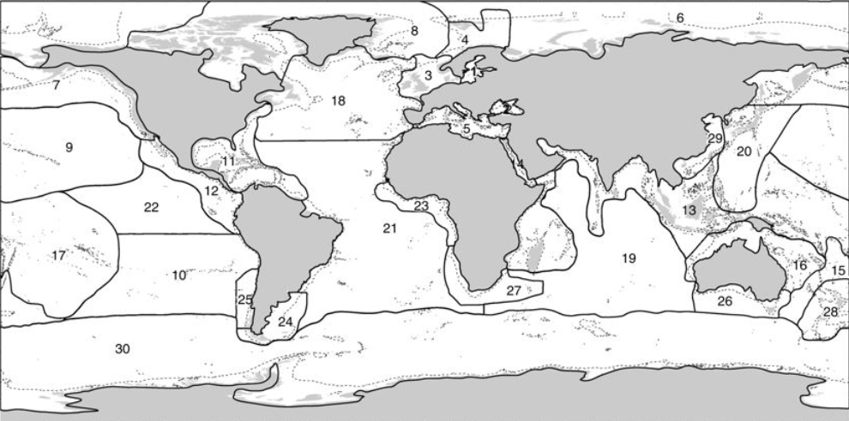

Figure S2. The map of the biogeographic Realms as numbered 1~30 (Costello et al., 2017).

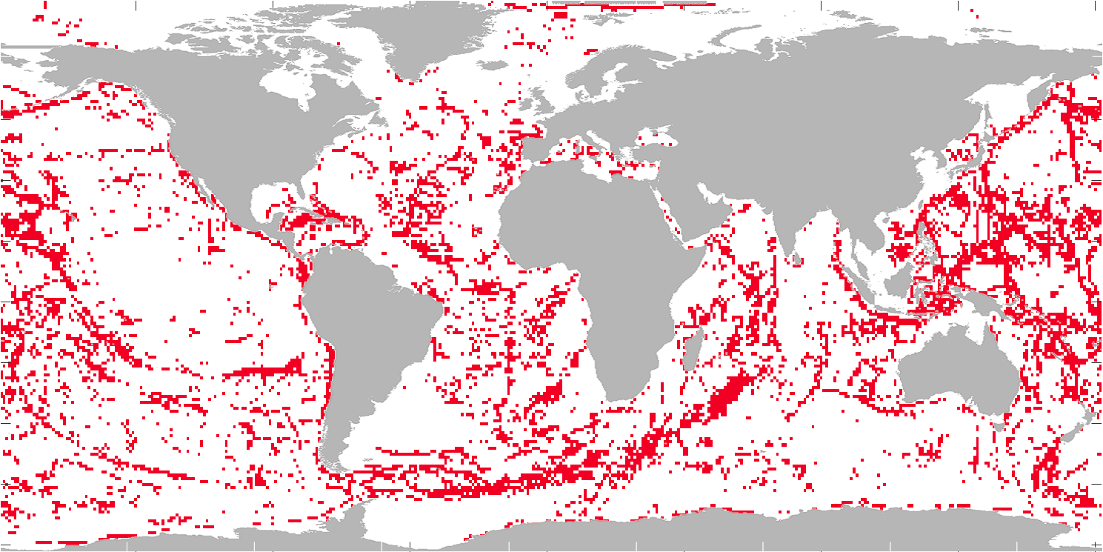

**a**

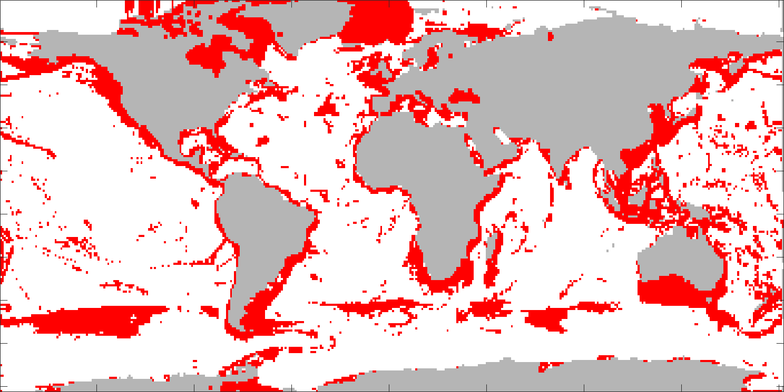

**b**

Figure S3. The red areas represent for (a) 30% highest rugosity, (b) 30% highest Within-Realm Species Richness.

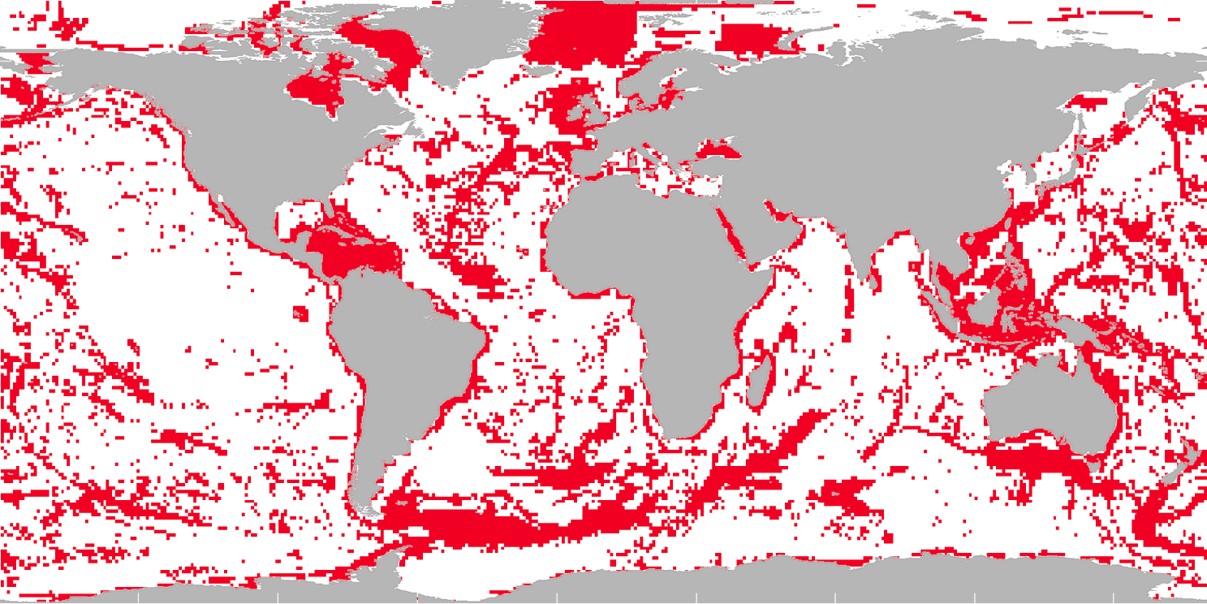

**a**

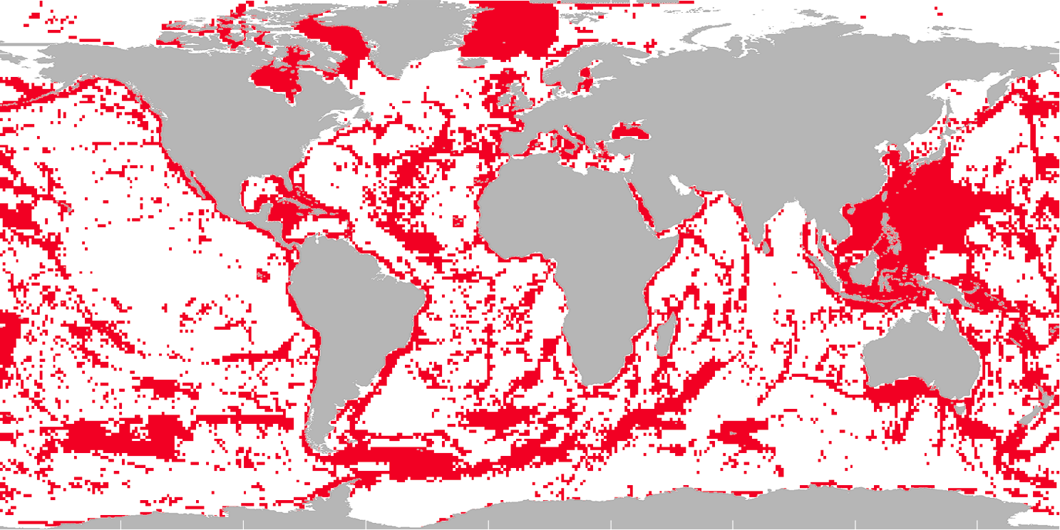

**b**

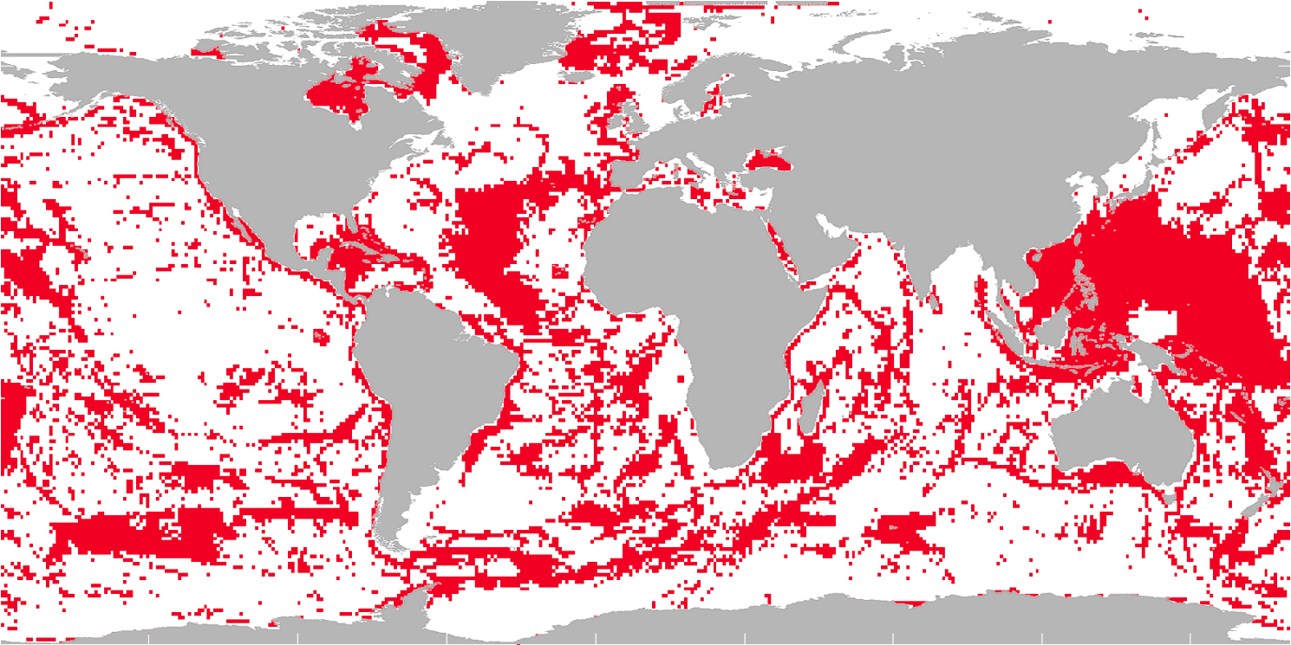

**c**

Figure S4. The maps of the 30% highest prioritization respectively by (A) the Target Based Function in Figure 4, (B) the Additive Benefit Function without weighing, and (C) the Additive Benefit Function with the weighing on Ecosystems based on their area size.

Table S2. The countries and/or regions whose Exclusive Economic Zone (The EEZs) areas (104×km2) overlapped the Prioritized Area, listed by the size of their EEZ. The percentage of each EEZ within the prioritized areas is also shown. The high percentages were highlighted in bold.

|  |  |  |
| --- | --- | --- |
| The EEZs | Area in the Prioritized Areas (104×km2) | % EEZ |
| Canada | 457.3 | 35 |
| Australia | 392.9 | 55 |
| United States | 380.2 | 36 |
| Greenland | 347.9 | 47 |
| Indonesia | 335.0 | 69 |
| Russia | 331.3 | 17 |
| New Zealand | 192.2 | 42 |
| **South Georgia & the South Sandwich Is.** | **180.2** | **86** |
| Svalbard | 165.6 | 51 |
| **French Polynesia** | **138.6** | **100** |
| Japan | 137.9 | 37 |
| **Philippines** | **117.2** | **77** |
| Brazil | 109.6 | 35 |
| Papua New Guinea | 109.1 | 56 |
| French Southern & Antarctic Lands | 97.7 | 40 |
| United States Minor Outlying Islands | 94.3 | 31 |
| Chile | 91.9 | 24 |
| Mexico | 85.1 | 30 |
| Micronesia | 82.3 | 34 |
| Norway | 81.3 | 40 |
| Portugal | 74.7 | 43 |
| United Kingdom | 73.7 | 69 |
| **Jan Mayen** | **72.0** | **99** |
| Marshall Is. | 69.6 | 42 |
| Solomon Is. | 66.0 | 50 |
| **Falkland Islands** | **64.8** | **100** |
| **Bouvet I.** | **60.7** | **99** |
| South Africa | 56.9 | 36 |
| Spain | 51.5 | 51 |
| **Ireland** | **51.0** | **90** |
| China | 50.5 | 62 |
| Saint Helena, Ascension en Tristan da Cunha | 48.9 | 32 |
| New Caledonia | 47.6 | 40 |
| Iceland | 44.9 | 32 |
| **Colombia** | **44.1** | **74** |
| Argentina | 43.4 | 34 |
| Seychelles | 42.4 | 39 |
| India | 42.2 | 22 |
| **The Bahamas** | **41.8** | **78** |
| Madagascar | 41.7 | 40 |
| Northern Marinana Islands-Guam | 36.4 | 44 |
| **Venezuela** | **36.3** | **92** |
| Vietnam | 35.8 | 67 |
| **Fiji** | **34.7** | **74** |
| Kiribati | 32.4 | 24 |
| Cook Is. | 31.4 | 19 |
| **Cuba** | **30.3** | **95** |
| Tonga | 30.1 | 52 |
| Heard I. & McDonald Is. | 27.0 | 48 |
| **Malaysia** | **26.6** | **73** |
| Faroe Is. | 25.4 | 35 |
| Vanuatu | 24.6 | 47 |
| Spratly Islands | 23.5 | 65 |
| Italy | 23.4 | 41 |
| Ecuador | 23.2 | 27 |
| Palau | 23.1 | 47 |
| **Dominican Republic** | **21.4** | **93** |
| **Jamaica** | **20.8** | **100** |
| Maldives | 20.2 | 27 |
| Mauritius | 20.2 | 19 |
| **France** | **19.8** | **100** |
| **Thailand** | **19.5** | **77** |
| **Sweden** | **19.5** | **74** |
| **Saudi Arabia** | **17.9** | **92** |
| Namibia | 17.0 | 34 |
| Yemen | 16.8 | 37 |
| **Honduras** | **16.7** | **90** |
| Panama | 16.7 | 61 |
| **Nicaragua** | **16.0** | **83** |
| Mozambique | 15.9 | 32 |
| Taiwan | 15.6 | 53 |
| Paracel Islands | 15.2 | 61 |
| **Ukraine** | **14.6** | **94** |
| Tuvalu | 14.3 | 23 |
| Myanmar | 14.0 | 32 |
| Peru | 13.9 | 20 |
| Greece | 13.7 | 27 |
| **Puerto Rico** | **13.3** | **89** |
| Wallis & Futuna | 13.3 | 62 |
| Somalia | 12.3 | 19 |
| American Samoa | 12.2 | 36 |
| Iran | 11.0 | 53 |
| Libya | 10.9 | 32 |
| Christmas I. | 10.7 | 40 |
| Conflict zone Japan/Russia | 10.6 | 44 |
| **Haiti** | **10.5** | **100** |
| **Denmark** | **10.5** | **71** |
| Western Sahara | 10.4 | 47 |
| Egypt | 10.3 | 42 |
| **Cayman Is.** | **10.2** | **100** |
| Oman | 10.1 | 22 |
| Finland | 10.0 | 9 |
| Sri Lanka | 9.5 | 22 |
| Angola | 9.3 | 23 |
| British Indian Ocean Territory | 9.1 | 17 |
| Turks & Caicos Is. | 9.0 | 66 |
| Tanzania | 9.0 | 38 |
| Morocco | 8.6 | 32 |
| Niue | 8.3 | 31 |
| Cocos Is. | 8.2 | 21 |
| Turkey | 7.9 | 29 |
| Costa Rica | 7.9 | 17 |
| Equatorial Guinea | 7.6 | 30 |
| Norfolk I. | 7.6 | 19 |
| Samoa | 7.5 | 69 |
| **Conflict zone China/Japan/Taiwan** | **6.6** | **100** |
| Pitcairn Is. | 6.4 | 9 |
| Guyana | 6.3 | 57 |
| French Guiana | 6.3 | 16 |
| Cape Verde | 6.3 | 9 |
| Senegal | 6.1 | 47 |
| **Sudan** | **5.7** | **99** |
| Tokelau | 5.7 | 22 |
| **Eritrea** | **5.6** | **84** |
| Germany | 5.1 | 64 |
| Mauritania | 4.8 | 36 |
| **Estonia** | **4.6** | **83** |
| Guadeloupe | 4.6 | 60 |
| Comoros | 4.6 | 33 |
| Tunisia | 4.4 | 44 |
| Kenya | 4.4 | 44 |
| Suriname | 4.2 | 40 |
| **Cambodia** | **4.0** | **100** |
| **Bulgaria** | **3.9** | **100** |
| Virgin Islands, British | 3.9 | 56 |
| Trinidad & Tobago | 3.8 | 62 |
| Netherlands | 3.8 | 44 |
| Bermuda | 3.8 | 9 |
| Antigua & Barbuda | 3.6 | 39 |
| Clipperton Island | 3.6 | 10 |
| Croatia | 3.3 | 53 |
| Anguilla | 3.3 | 41 |
| **Latvia** | **3.2** | **75** |
| **United States Virgin Islands** | **3.1** | **100** |
| **Saint Vincent and the Grenadines** | **3.0** | **100** |
| **Romania** | **3.0** | **89** |
| Algeria | 3.0 | 23 |
| Pakistan | 3.0 | 15 |
| **Belize** | **2.7** | **88** |
| South Korea | 2.7 | 8 |
| Martinique | 2.6 | 65 |
| Joint regime Japan/Korea | 2.6 | 33 |
| Nigeria | 2.6 | 17 |
| **Curaçao** | **2.5** | **100** |
| **Timor-Leste** | **2.5** | **71** |
| Poland | 2.5 | 57 |
| **Qatar** | **2.4** | **84** |
| Nauru | 2.4 | 10 |
| Gabon | 2.3 | 15 |
| **Grenada** | **2.2** | **100** |
| Cote d'Ivoire | 2.2 | 16 |
| **Aruba** | **2.1** | **100** |
| United Arab Emirates | 2.1 | 43 |
| Mayotte | 2.1 | 40 |
| Sao Tome & Principe | 2.1 | 19 |
| Barbados | 2.0 | 13 |
| Ghana | 2.0 | 11 |
| **Bonaire, Sint-Eustasius, Saba** | **1.9** | **100** |
| **Brunei** | **1.9** | **90** |
| **Georgia** | **1.9** | **78** |
| Bangladesh | 1.9 | 26 |
| **Dominica** | **1.8** | **73** |
| El Salvador | 1.8 | 24 |
| Guinea | 1.8 | 20 |
| **Joint regime Colombia/Jamaica** | **1.5** | **100** |
| Area of overlap Australia/Indonesia | 1.5 | 40 |
| Reunion | 1.4 | 5 |
| **St. Lucia** | **1.3** | **100** |
| North Korea | 1.3 | 10 |
| **Cameroon** | **1.2** | **87** |
| **Guernsey** | **1.1** | **100** |
| The Gambia | 1.0 | 53 |
| Guatemala | 1.0 | 11 |
| Uruguay | 1.0 | 7 |
| Liberia | 1.0 | 5 |
| **St. Kitts & Nevis** | **0.9** | **100** |
| Congo | 0.9 | 28 |
| Albania | 0.8 | 68 |
| Conflict zone Japan/South Korea | 0.8 | 12 |
| Guinea-Bissau | 0.8 | 9 |
| Joint development area Australia/East Timor | 0.7 | 26 |
| Sierra Leone | 0.7 | 6 |
| **Montserrat** | **0.6** | **100** |
| Kuwait | 0.6 | 49 |
| **Saint Martin** | **0.5** | **100** |
| **Bahrain** | **0.5** | **76** |
| Djibouti | 0.4 | 68 |
| Lebanon | 0.4 | 22 |
| Congo, DRC | 0.4 | 16 |
| **Protected zone Australia/Papua New Guinea** | **0.3** | **100** |
| Togo | 0.3 | 27 |
| Benin | 0.3 | 14 |
| Disputed Kenya/Somalia | 0.3 | 7 |
| Cyprus | 0.3 | 4 |
| **Netherlands Antilles** | **0.2** | **100** |
| Jersey | 0.2 | 42 |
| Lithuania | 0.2 | 24 |
| Disputed Western Sahara/Mauritania | 0.2 | 5 |
| **Singapore** | **0.1** | **100** |
| **Iraq** | **0.1** | **100** |
| **Sint Maarten** | **0.0** | **100** |
| **Gibraltar** | **0.0** | **100** |
| **Slovenia** | **0.0** | **100** |
| **Jordan** | **0.0** | **100** |
| **Monaco** | **0.0** | **79** |
| Syria | 0.0 | 4 |
| Malta | 0.0 | 0 |
| Israel | 0.0 | 0 |

**Reference:**

Basher, Z., Bowden, D. A., & Costello, M. J. (2014). *Global Marine Environment Datasets (GMED)*. Retrieved from: http://gmed.auckland.ac.nz

Costello, M. J., Tsai, P., Wong, P. S., Cheung, A. K. L., Basher, Z., & Chaudhary, C. (2017). Marine biogeographic realms and species endemicity. *Nature communications, 8*(1), 1057.

Kaschner, K., Kesner-Reyes, K., Garilao, C., Rius-Barile, J., Froese, R., & Rees, T. (2016). *AquaMaps: Predicted range maps for aquatic species*. Retrieved from: www.aquamaps.org

Zhao, Q., Basher, Z., & Costello, M. (2019). Mapping near surface global marine ecosystems through cluster analysis of environmental data. *Ecological Research*. doi:10.1111/1440-1703.12060